Online Conferences VI

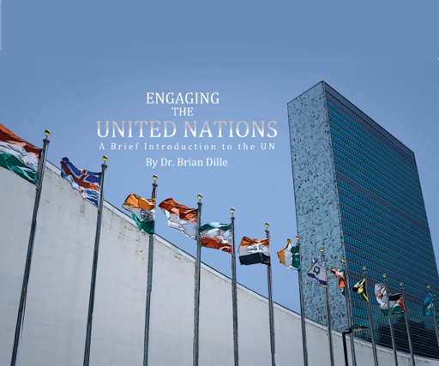

Exam Copy – www.engagingtheun.com

Sample Instructor’s guide with online exercises
email engagementlearning@gmail.com

Today we discussed chair training and conference management.

Upcoming Fall Conferences

Florida MUN Oct 17
Contact Doug Ryan FMUN.org

SRMUN Atlanta Oct. 23-Oct 25.
Visit srmun.org/atlanta for info.

COCMUN October 24th and 25th
www.canyons.edu/cocmun
Contact Phil Gussin phil.gussin@canyons.edu

NMUN-DC Nov 6-8
Info at NMUN.ORG

Teton County MUN (HS) Nov 16-17
www.tcmun.org

MCCMUN Sonoran Desert Conference Nov 20 and 21
https://www.mesacc.edu/departments/social-science/model-un/sonoran-desert-conference
Contact Brian Dille bdille@mesacc.edu
Thinking about Rules changes for an online conference

Chair Training

Live
Recruit veterans to chair, provide leadership to new delegates. Chairs research and write policy briefs for committee topics – ensures subject matter expertise. Chairs evaluate written policy statements submitted prior to conference.

Meet weekly for training month prior to conference to ensure common understanding of the rules. Practice sessions where secretariat walks chairs through scenarios and transitions. Socialization on chair ethics.

By the time conference starts, chairs are competent and confident.

Online
Difficulties
With cancellation of Spring 2020 conferences, we missed a cohort of veterans to draw from.
Many conferences are rolling over 2020 topics, which means at least some chairs will not have developed the topic expertise because they didn’t write the policy brief.
Socialization will look different with no in-person peer pressure
Committee cohesion may be an issue

Advantages
Freed from geographic constraint, so chairs can be drawn from anywhere – other schools, alumni.
Much of the training can be asynchronous, content-driven
The logistic and emotional complexities of online chair training mirror those of running an online conference, so their experience will be appropriate training

How to
Like all online pedagogy, chair training will have to be more structured. Can’t fly by seat of your pants! Prepare materials, structure sequence, and assess understanding.

MCC Instructional videos
- Roles of chairs
  - Philosophy
    - Chairs as neutral facilitators
    - Chairs as Mentors/teachers - be kind, supportive
  - Chair duties
  - General powers of the chair
  - Models for sharing the gavel
- Types of debate
  - General
  - Substantive
  - Voting Bloc
- Opening a meeting
  - Roll call
  - Reordering the agenda (first day)
  - Speakers lists
  - Housekeeping
- Debate and caucusing
  - Time management
  - Speeches, comments, points of inquiry
  - Uses of P-25
  - Moderated caucus
  - Unmoderated caucus
  - Order of motions
- Decorum
  - Debate decorum
  - Dress decorum
  - Right of reply
- Transitions
  - Adjournment of debate
  - Suspension of debate
  - Closure of an agenda item
  - Adjournment of meeting (final day)
- Resolutions and voting
  - Formatting
  - Working papers
  - Draft Resolutions
  - Amendments
  - DPI
  - Voting Bloc procedures

Continue to have them review submitted policy statements as normal – this was an online process anyway, so little different. We use a google sheet to compile scores.
Practice, practice, practice – The only way to learn is by doing
Discussion Notes
Lindsey Ehlinger– I created a short google form with two questions for chairs: What are your concerns for chairing online this year (esp. for new chairs), and what advice do you have for new chairs (aimed at experienced chairs).
The results showed that confidence is the key to the chairing experience. They attended a one day conference in September, even if just observing, they will be able to evaluate and prepare.

Lindsey - Everything is so new, so we need to instill an attitude, not aptitude. Mistakes will happen, just roll with it – don’t pout. Lots of people are doing things they are not confident with right now.

Rosanna Perotti acknowledged the need for structure - I'm an adviser; our students typically run everything, and I'm realizing that the formality required may be too much for them to handle on their own.

Upcoming Topics

Nov 10 11 am EDT
Commiseration

Dec 1 11 am EDT
Commiseration

