Online Conferences II

Today we talked about the pros and cons of the various conferencing tools (Zoom, Webex, Discord, Google Teams, Gatherly, Adobe Connect)

Upcoming Fall Conferences

Florida MUN Oct 17
See fmun.org for info

SRMUN Atlanta Oct. 23-Oct 25.
see srmun.org/atlanta for info.

COCMUN October 24th and 25th
Contact Phil Gussin phil.gussin@canyons.edu

NMUN-DC Nov 6-8
See NMUN.ORG for info

MCCMUN Sonoran Desert Conference Nov 20 and 21
Contact Brian Dille bdille@mesacc.edu

Discussion notes and chat

Refer to the linked spreadsheet to see the functionality comparison across the various tools. I made this a google doc to enable updates. If you want to add or change information on the spreadsheet, just click the request editing access link and I’ll grant it.
https://drive.google.com/file/d/1iO0yH-CgFlnyM9pwZ_BTAhP-xZYnpi6K/view?usp=sharing

Closed Captioning – There was some conflicting information on whether any of the tools can close caption live on the fly. Most of the tools will auto-caption meeting recordings. Zoom reportedly worked on the fly, but Katie said that she had to use a stenographer to enter the captions live.

There was a great discussion about waivers/permission forms for minors. The major tools have security baked in since high schools are using them. It would be prudent for a conference organizer to know what those are. I added a data security/privacy row on the spreadsheet.

Won't claim to know everything about zoom, but I do use it frequently with some more advanced features, happy to answer any questions, klbehnke@alaska.edu

Upcoming Topics

Sept 1 11 am EDT
Recruiting and strategies to enhance engagement

Sept 15 11 am EDT
Running a plenary and committees caucus

Sept 29 11 am EDT
Rule changes to facilitate the online experience

Oct 13. 11 am EDT
Chair training and conference management

Nov 10 11 am EDT
Commiseration

Dec 1 11 am EDT
Commiseration

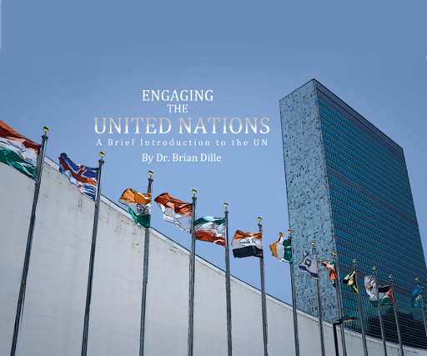

Exam Copy – www.engagingtheun.com
Sample Instructor’s guide with online exercises
engagementlearning@gmail.com

